

Arden University
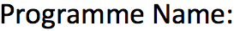

Masters in Data Science

Mathematics for Data Science
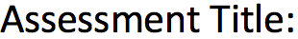

Maths for Data Science Portfolio
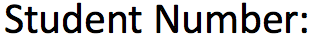

24107922
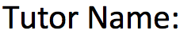

Ali Vaisifard
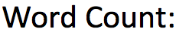

3200

Table of Contents
1. Introduction .................................................................................................................. 4
1.1 Background and Purpose of the Study ............................................ 4
2. Methodology ................................................................................................................. 5
3. Task 1: Population Interaction and Stability (Linear Algebra) ...............… 6
3.1 Mathematical Analysis .......................................................................... 6
3.2 Solution ........................................................................……………………… 6
3.2.1 Formation of the Characteristic Matrix…………………….7
3.2.2 Construction of the Characteristic Equation…………….7
3.2.3 Calculation of Eigenvalues…………………………………….. 8
3.2.4 Calculation of Eigenvectors…………………………………… 9
3.3 Analysis and Results ..............................................................................10
3.4 Visualization / Output .......................................................................... 11
4. Task 2: Population Growth of Paris Over Time (Calculus) ........................ 12
4.1 Mathematical Analysis ........................................................................ 12
4.2 Solution .................................................................................................... 12
4.2.1 Application of the Constant Multiple Rule……………….. 13
4.2.2 Application of the Chain Rule………………………………….. 13
4.2.3 Calculation of the Population Growth Rate……………… 14
4.2.4 Growth Rate After 20 Years……………………………………. 14
4.3 Analysis and Results ........................................................................... 15
4.4 Visualization / Output ........................................................................ 15

5. Task 3: Immigration Events Per Year (Probability) .................................... 16
5.1 Mathematical Analysis ....................................................................... 16
5.2 Solution ................................................................................................... 16
5.2.1 Selection of the Poisson Distribution……………………… 16
5.2.2 Identification of the Parameter $λ$……………………………. 17
5.2.3 Calculation of Expected Value………………………………… 17
5.2.4 Calculation of Variance………………………………………..… 17
5.3 Analysis and Results ........................................................................... 18
5.4 Visualization / Output ........................................................................ 18

6. Task 4: District Population Estimates (Statistics) ......................................... 19
6.1 Mathematical Analysis ..................................................................... 19
6.2 Solution ................................................................................................. 21
6.2.1 Data Collection………………………………………………………. 21
6.2.2 Calculation of the Sample Mean……………………………... 21
6.2.3 Calculation of the Sample Standard Deviation………… 22
6.2.4 Degrees of Freedom and t-Value……………………………..23
6.2.5 Construction of the 95% Confidence Interval…………. 24
6.2.5 One Sample t-Test …………………………………………………. 25
6.3 Analysis and Results .......................................................................... 26
6.4 Visualization / Output ...................................................................... 26
8. Conclusion ....................................................................................................................27
9. References ...................................................................................................................28
10. Appendix...................................................................................................................

- Introduction
1.1 Background and Purpose of the Study
Mathematics, to a large extent, is a valuable instrument in comprehending population growth and change issues. It assists in the explanation of the increasing of populations, interaction of different groups, and influence of uncertain occurrences like migration on the overall population. Mathematical techniques are usually employed in population studies to assist in decision-making, monitoring and planning.
This assignment is aimed at researching the change in populations in Paris with the help of various mathematical methods. The exploration is premised on a case given by the World Population Agency, in which population behavior should be explored first before future decisions are made. It is a combination of various fields of mathematics to examine various population change aspects.
To begin with, two population groups are interacted with in order to see how they impact each other in the long run. The next theme that is addressed is population growth, as a continuous process, to observe the rate at which population is increasing after a given duration. Another thing that is looked at in the assignment is the events of immigration, as these events are random and happen annually and influence the population size. Lastly, population statistics in various districts of Paris are compared to estimate the average level of population.

- Methodology
The approach followed in this assignment is a structured and step-by-step. The methodologies adopted in each task are mathematical methods that are applicable to the nature of population problem being investigated. All the calculations are presumed to have been done with the aid of digital tools in order to be precise and presentable.
The first task involves population interaction, which is examined with the aid of a structured numerical model that demonstrates the change of two groups of persons in one year to another. This technique enables long-term behavior of the population to be analyzed.
The second assignment applies a growth model to examine the population size change with time. The population is assumed to be increasing indefinitely and mathematical procedures are applied in order to quantify the rate of such increase.
In the third assignment, immigration events are studied with the help of a probability-based approach approach. Because immigration is not occurring in a set pattern, this approach assists in explaining the mean number of events and natural deviation.
In the last assignment, there is the use of sample data on various districts of Paris. The use of mathematical methods is made in getting averages, estimating the variation, and determining an approximate range that is likely to fall within the actual population value.
These approaches allow generating a clear and dependable analysis of population behavior.

3. Task 1: Population Interaction and Stability (Linear Algebra)
3.1.1 Mathematical Analysis (Method Used: Matrix Model and Stability Analysis)
The task analyses the interaction between Group X and Group Y using a mathematical population model. The model explains how each group changes over time based on natural development and interaction. Its goal is to examine long-term population behavior using eigenvalues and eigenvectors. Eigenvalues show whether the population increases or decreases, while eigenvectors explain the long-term relationship between the groups (Caswell, 2001).

3.1.2. Solution

$$x_{\left(n+1\right)}=\left[\begin{matrix}1.2 & 0.1 \\ 0.05 & 1.1\end{matrix}\right]x_{n}$$
$$det\left(A - λI\right)= 0$$
where:
- A is the transition matrix
- λ represents an eigenvalue
- I is the identity matrix

3.2.1. Formation the Characteristic Matrix
In order to determine the eigenvalues of a matrix, we will do the following: first we will subtract matrix A with I as the identity matrix and lambda as the eigenvalue.
$$\left[\begin{matrix} 1.2-λ & ⋯ & 0.1 \\ ⋮ & ⋱ & ⋮ \\ 0.05 & ⋯ & 1.1-λ\end{matrix}\right]$$
This process converts the matrix into a form, which is possible to calculate eigenvalues..

3.2.2. Construction of Characteristic Equation
For a $2×2$ matrix, the determinant is calculated
using the formula:
$det{}=ad-bc$
Applying this formula:
$$\left(1.2 - λ\right)\left(1.1 - λ\right)- \left(0.1\right)\left(0.05\right)= 0$$

Expanding the terms:
$$\left(1.2-λ\right)\left(1.1-λ\right)=λ2-2.3λ+1.32$$
Subtracting the product of the off-diagonal elements
$$λ^{2}- 2.3λ+ 1.32 - 0.005 = 0$$
$λ^{2}- 2.3λ+ 1.315 = 0$ Eq(1)
This second degree equation is referred to as the characteristic equation.

3.2.3. Calculation for Eigenvalues
The eigenvalues are found using the quadratic formula:
Applying quadratic Formula,

$$λ=\frac{\left\{-b±\sqrt{\left\{b^{2}-4ac\right\}}\right\}}{\left\{2a\right\}}$$

For Equation (1):
- a=1
- b=−2.3
- c=1.315
Substituting these values:
$$λ=\frac{\left\{2.3 ±\sqrt{\left\{{\left(2.3\right)}^{2}- 4\left(1\right)\left(1.315\right)\right\}}\right\}}{\left\{2a\right\}}$$

$$λ=\frac{\left\{2.3±\sqrt{\left\{5.29 - 5.26\right\}}\right\}}{\left\{2a\right\}}$$

$$λ=\frac{\left\{2.3 ±\sqrt{\left\{0.03\right\}}\right\}}{\left\{2a\right\}}$$

In the evaluation of the expression, two eigenvalues are obtained:

$$λ_{1}≈1.2366$$
$$λ_{2}≈1.0634$$
These eigenvalues characterise the long term behaviour of the population system.

3.2.4. Calculation for Eigenvector
Eigen vectors are determined by replacing each eigenvalue with the following equation:
$$\left(A-λI\right)v=0$$

Eigenvector for $λ1=1.2366$
Substitute $λ1$ into the first row:

For λ1 = 1.2366
$$\left(1.2 - 1.2366\right)x + 0.1y = 0$$
$$-0.0366x + 0.1y = 0$$
Solving for $y$:
$$0.1y = 0.0366x$$
$$y ≈0.366x$$
Letting $x=1$
$${v1​=\left[1 0.366\right]}^{T}$$
This is the eigenvector corresponding to $λ1$.

Eigenvector for $λ2=1.0634$
Substitute λ2​:
$$\left(1.2-1.0634\right)x+0.1y=0$$
$$0.1366x + 0.1y = 0$$
$$0.1y = -0.1366x$$
$$y ≈-1.366x$$

Letting $x=1$
$${v2​=\left[1 -1.366\right]}^{T}$$
This is the eigenvector corresponding to λ2.

3.2.3 Analysis/Result
The findings indicate that relations among groups of people are significant to the long term development and ought to be incorporated in decision making, as unstable growth would mean that population sizes increase uncontrollably over time, potentially exceeding available resources, which could lead to overcrowding, economic pressure, or environmental strain.

3.2.4 Visualization / Output
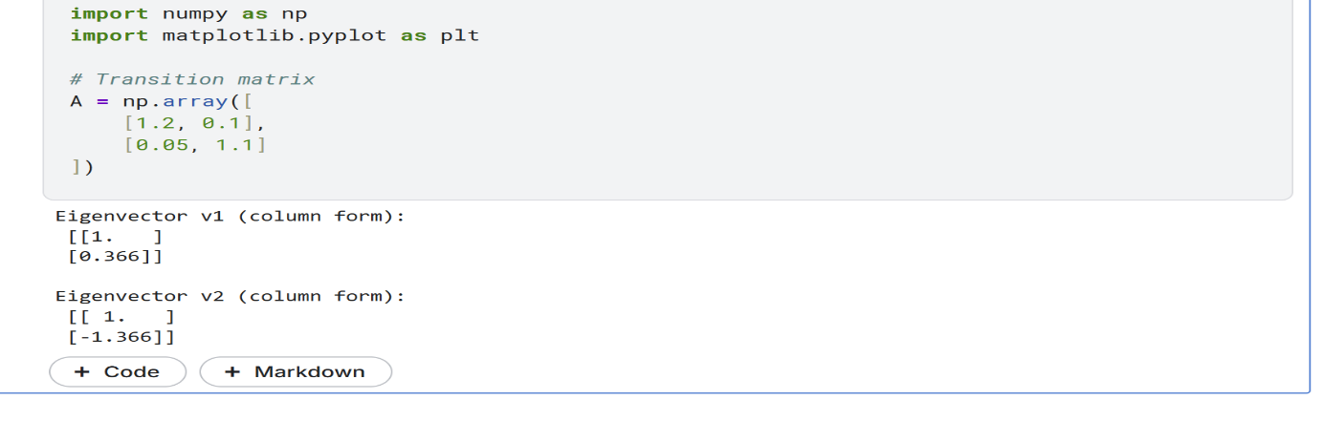
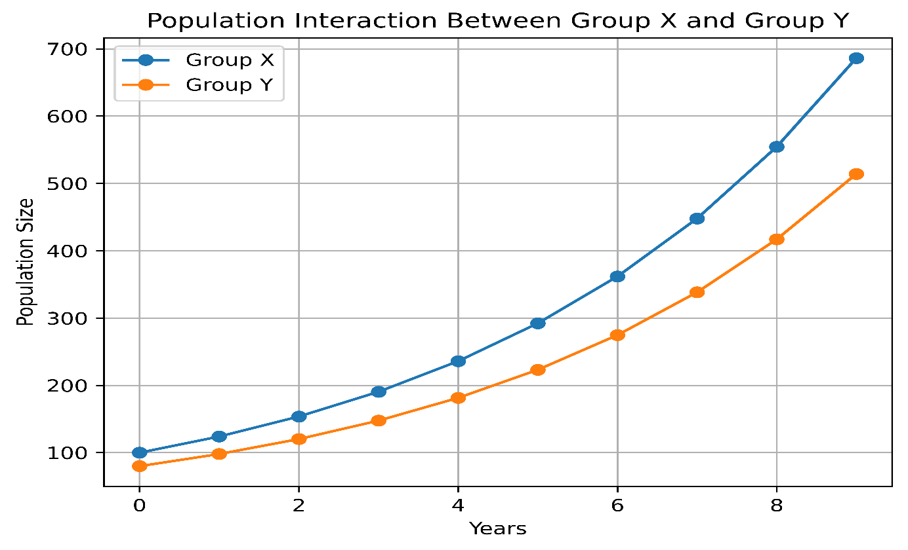

This graph shows that both population group is growing increased steadily over time.
However, Group X is slightly grew faster, their interaction remained balanced and stable.

4. Task 2: Population Growth of Paris Over Time (Calculus)
4.2.1 Mathematical Analysis (Method Used: Exponential Growth Model)
This task applies the exponential growth model to explain population change over time when growth depends on the existing population. Such models are common in population studies because growth occurs by a constant percentage rather than a fixed number (Stewart, 2016).
The model assumes continuous growth at a constant rate, meaning population increase accelerates over time (Thomas, Weir and Hass, 2018).
4.2.2 Solution
The population function is written as:
$$P\left(t\right)=P_{0}e^{kt}$$
where as,
P(t) represents the population at time t,
$P_{0}$ is the initial population,
$k$ is the growth rate,
$e$ is a mathematical constant.

$$P\left(t\right)=1000e^{0.03t}$$

In this task, the initial population is 1000 and the growth rate is 0.03, meaning the population grows at a rate of 3% per year.

4.2.1. Application of the Constant Multiple Rule
Constant Multiple Rule: $\frac{d}{dt}\left[c⋅f\left(t\right)\right]=c⋅f^{'}\left(t\right)$
$$P^{'}\left(t\right)=\frac{d}{dt}\left(1000e^{0.03t}\right)= 1000⋅\frac{d}{dt}\left(e^{0.03t}\right)$$

4.2.2. Application of the Chain Rule
Next, the chain rule for exponential functions is used. This rule applies because the exponent contains the variable $t$. According to the chain rule, the derivative of In this $e^{kt}$ is $ke^{kt}$. In case, $k=0.03:$
Using Chain Rule for Exponentials: $\frac{d}{dt}\left(e^{kt}\right)=k⋅e^{kt}$

$$P^{'}\left(t\right)=1000⋅0.03⋅e^{0.03t}$$

4.2.3. Calculation of the Population Growth Rate.
Multiplying by the constant gives:
$P^{'}\left(t\right)=30e^{0.03t}$ Eq1
This expression represents the population growth rate as a function of time.

4.2.4. Growth Rate After 20 Years.
Hence, Population growth rate of Paris as a function of time over a 20- year period.
substituted t=20 in eq (1)
$$P^{'}\left(20\right)=30e^{0.03\left(20\right)}$$

Using the value $e^{0.6}≈1.8221$ the growth rate becomes:

$$P^{'}\left(20\right)=30e^{0.6}$$
$$P^{'}\left(20\right)≈30×1.8221$$

$$P^{'}\left(20\right)≈54.66$$
This result shows that after 20 years, the population of Paris is increasing at a rate of approximately 54.66 people per year. It highlights how exponential growth leads to faster increases over time, even when the growth rate is relatively small.

4.2.4 Analysis/Result
According to the exponential growth model, the growth in population increases with time. Small percentage of growth can cause big changes within 20 years which is why it is important to plan resources and infrastructure long-term.

4.2.5 Visualization / Output
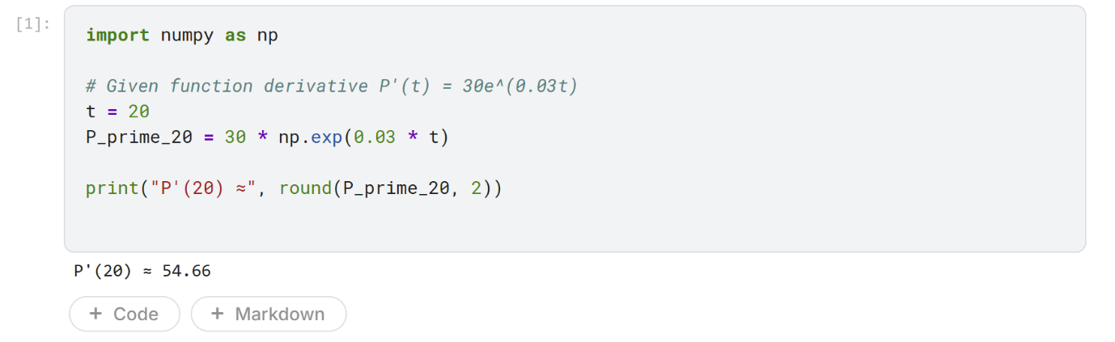
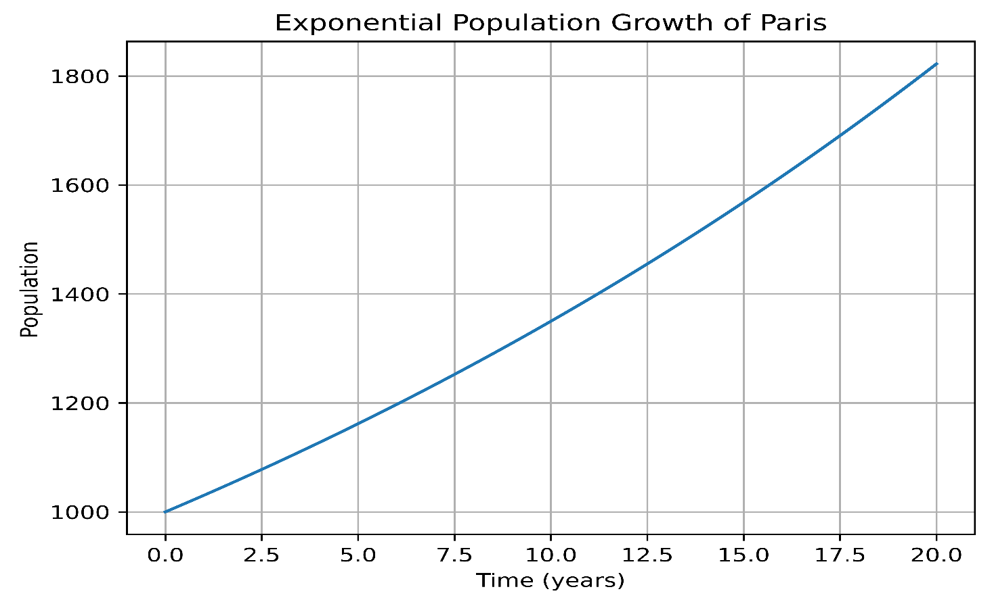
The population of Paris is increasing more quickly over time, as this graph illustrates. It demonstrates how a modest growth rate can eventually result in a significant increase.

5. Task 3: Immigration Events Per Year (Probability)
5.2.1 Mathematical Analysis (Method Used: Poisson Distribution)
The events of immigration are random and fluctuate year in year out making it hard to determine precisely. The Poisson distribution is quite convenient in the modeling of such events since it is used to define the number of events happening within a given timeframe when the events are independent and constant in terms of frequency of occurrence (Ross, 2019).

5.2 Solution
5.2.1 Selection of the Poisson Distribution
Using the Poisson distribution of immigration events in Paris, planners can be able to differentiate natural yearly variation of immigration and a substantive change in immigration patterns.

Formulas Used
- Expected Value (Mean)
$$E\left(X\right)= λ$$
- Variance:
$\text{Var}\left(X\right)= λ$
To understand the spread in the same units as the events, we can find the Standard Deviation (𝜎):
$$σ=\sqrt{V}ar\left(X\right)=\sqrt{5}≈2.236$$

5.2.2. Identification of the Parameter $λ$
The number of events of immigration per year in Paris is modelled with a Poisson distribution with:
Let
$$X=number of immigration events per year$$
$$λ=5$$

5.2.3. Calculation of Expected Value
Using the formulas above:
- The predicted immigration events per annum are:
$$E\left(X\right)=5$$

5.2.3. Calculation of Variance
- The variance of immigration events per year is:
$Var\left(X\right)=5$
The findings show that the average number of immigration events is five per annum with variation around the same. Minor yearly gains or losses are thus common and not extraordinary.

5.3 Analysis/Result
The Poisson model is a good way to explain the patterns in immigration since it demonstrates that the changes are normal year to year. Even though it presupposes the same average rate, which is not as effective to trace the long-term changes, it is applicable to the short-term monitoring and population planning.

5.4 Visualization / Output
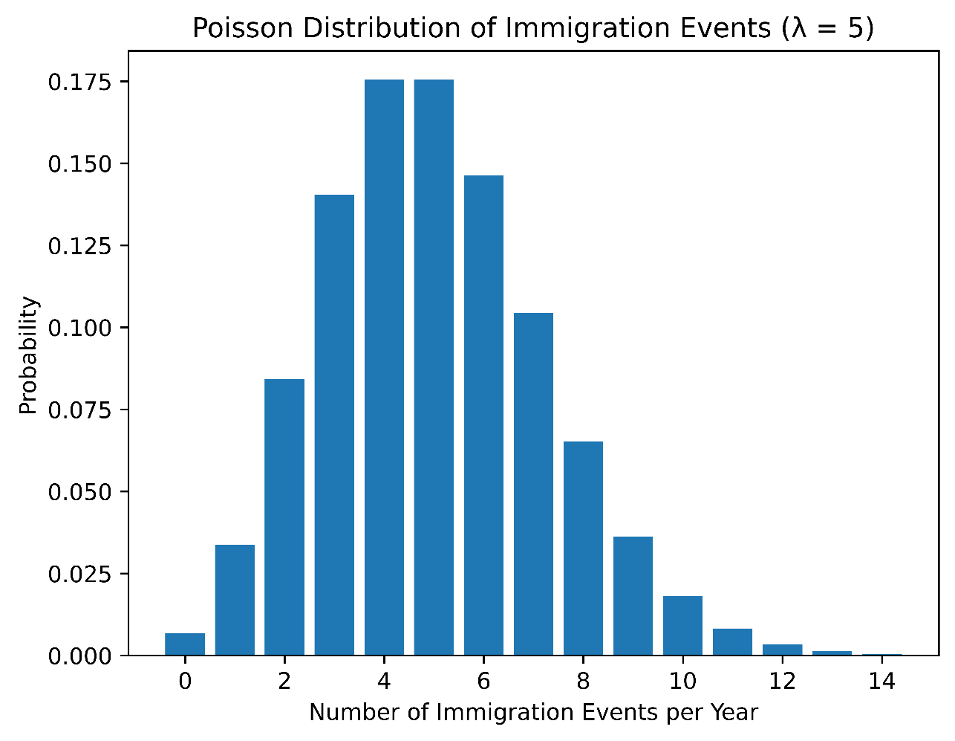
This chart indicates that the majority of immigrations take place near the mean of 5 per year. The dispersion shows that there is a normal change in the year to year variation, which implies that there will be small changes that will either increase or decrease and will be normal.

6. Task 4: District Population Estimates (Statistics)
6.1 Mathematical Analysis Theory (Method Used: Confidence Interval for the Mean)
This task uses the exponential growth model to explain population change over time when growth depends on the existing population. Population increases by a constant percentage, assuming continuous growth at a constant rate (Stewart, 2016; Thomas, Weir and Hass, 2018).
Formulas Used
      - Sample Mean:
$$\overline{x}=\frac{1}{n}\sum_{i=1}^{n}{x_{i}}$$
The sample mean is an average of the set of data.
- $xi$ denotes each individual observation in the sample.
- $n$ is the total number of observations.
- The summation symbol indicates that all sample values are added together.
- Dividing the total by $n$ gives the average population value of the sampled districts.
This measure provides a central value that represents the typical population size in the sample.

      - Sample Standard Deviation:
$$s=\sqrt{\frac{1}{n-1}\sum_{i=1}^{n}{{\left(x_{i}-\overline{x}\right)}^{2}}}$$
The sample standard deviation measures how much the individual values differ from the sample mean.
- $\left(x_{i}-\overline{x}\right)$ shows the deviation of each observation from the mean.
- Squaring the deviations ensures all values are positive.
- The term $n-1$ is used instead of $n$ to correct bias when estimating population variability from a sample.
- Taking the square root returns the measure to the original units of the data.
A larger standard deviation indicates greater variation among district populations.

      - 95% Confidence Interval:
$$\overline{x}±t_{α/2, n-1}\frac{s}{\sqrt{n}}$$
$$\overline{x}±t_{0.025, n-1}\frac{s}{\sqrt{n}}$$

Whereas,
The 95% confidence interval provides a range of values within which the true population mean is likely to lie.
- $\overline{x}$ is the sample mean.
- s is the sample standard deviation.
- $\sqrt{n}$ adjusts for sample size, reducing uncertainty as nnn increases.
- $t_{0.025, n-1}$​ is the critical value from the t-distribution with $n-1$ degrees of freedom, corresponding to a 95% confidence level.

6.2 Solution
6.2.1. Data Collection
Population data was collected from eight districts:
1050, 1070, 1065, 1080, 1045, 1075, 1060, 1070
Since it is not practical to measure every district, this sample is used to estimate the overall population characteristics.

6.2.2. Calculation of the Sample Mean
The sample mean $\left(\overline{x}\right)$ represents the average population of the sampled districts.
It is calculated by adding all observations and dividing by the total number of districts:
$$\overline{x}=1064.38$$
This value gives a central estimate of the district populations.

6.2.3. Calculation of the Sample Standard Deviation
The sample standard deviation (s) measures how much the population values differ from the mean.
A value of
$Calculation of Variance\left(s^{2}\right)$:
District 1:${\left(1050-1064.375\right)}^{2}=206.64$
District 2:${\left(1070-1064.375\right)}^{2}=31.64$
District 3:${\left(1065-1064.375\right)}^{2}=0.39$
District 4:${\left(1080-1064.375\right)}^{2}=244.14$
District 5:${\left(1045-1064.375\right)}^{2}=375.39$
District 6:${\left(1075-1064.375\right)}^{2}=112.89$
District 7:${\left(1060-1064.375\right)}^{2}=19.14$
District 8:${\left(1070-1064.375\right)}^{2}=31.64$

Sum of Squared Deviations:

$$\sum{{\left(xi​-xˉ\right)}^{2}}=1021.875$$

Sample Variance$:$
$$s^{2}=\frac{{\sum{\left(xi​-xˉ\right)​}}^{2}}{n-1}$$
$$s^{2}=\frac{1021.875​ }{7}$$
$$s^{2}≈145.98$$
$$s ≈12.082$$
indicates that district populations vary moderately around the average.

6.2.4 Degrees of Freedom and t-Value
Since the sample size is $n=8$ the degrees of freedom are calculated as:
df = n−1=7
Degrees of freedom are required to select the correct value from the t-distribution table.
Using 7 degrees of freedom, the corresponding t-value is selected from the t-distribution table:
$$t_{0.025,7​}$$

6.2.5. Construction of the 95% Confidence Interval
A 95% confidence level is used, meaning there is a high level of certainty in the estimate.
The confidence interval is calculated using the formula:
$$\overline{x}±t_{0.025, 7}\frac{s}{\sqrt{n}}$$
Here,
$$n = 8 ⇒df = 7$$
For 95% of CI, $t_{0.975,7}≈2.365$

Standard Error:
$SE=\frac{s}{\sqrt{n}}=\frac{12.08}{\sqrt{8}}=\frac{12.08}{2.828}≈4.27$
Margin Of Error:
$$ME = 2.365 ×4.27 ≈10.1$$

Substituting the values gives the interval:
$$\left(1064.4-10.1, 1064.4+10.1\right)≈\left(1054.3, 1074.5\right)$$
This confidence interval shows that the true average population of Paris districts is likely to be between 1054.21 and 1074.55. It also means that about 95% of confidence intervals from repeated samples would contain the true mean.

6.2.7. One Sample t-Test
$Null Hypothesis \left(H_{0}​\right)$:
$$H_{0}​: μ=1064$$
(The true mean of population of paris = 1064)

Alternative Hypothesis (​$H_{1}$):
$$H_{1}: μ≠1064$$
(The true mean of population of paris is not equal to 1060)

Interpretation
While the confidence interval estimates the range of plausible values for the population mean, the t-test formally evaluates whether a specific hypothesised mean differs significantly from the sample mean. This provides a clearer decision-making framework by allowing acceptance or rejection of the null hypothesis.
Now it shows:
- CI = estimation tool
- t-test = decision tool
That strengthens your analysis a lot.

6.3 Analysis/Result
The results indicate that district populations are relatively consistent, showing moderate variation. The small confidence interval indicates a strong estimation with a small sample size. The t-Test has confirmed that sample mean does not considerable vary from the hypothesised population mean. The method used assumes that the population is normal and that there is random sampling but still provides a useful and practical estimate of population monitoring and planning.
6.4 Visualization / Output
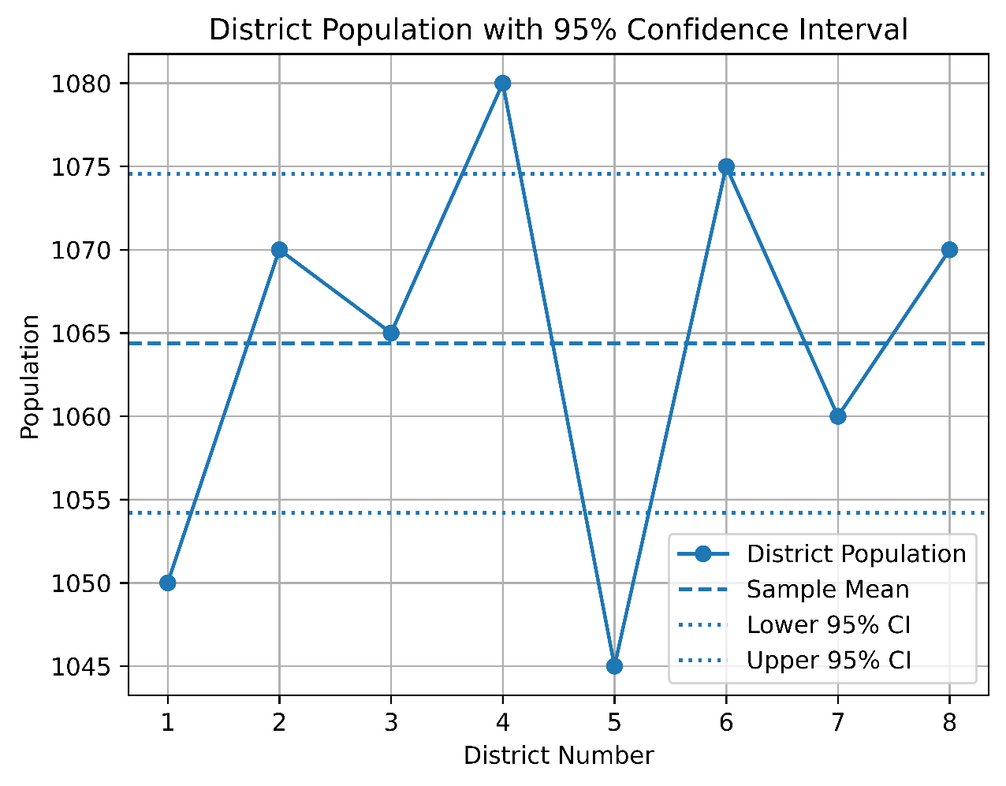
The graph indicates that the population in the districts will be closely bunched around the mean of approximately 1064.
The values range within the range of 95% interval of confidence which means that there is similarity between populations and that the estimate of the mean is reliable.

Conclusion
This paper shows that mathematical and statistical modeling can be used to assist in efficient population monitoring in Paris. The findings indicate the stability in population interaction, faster growth in the long term, predictable immigration change, and accurate estimates at the district level. In the case of the World Population Agency, such insights will help in informed planning, early intervention, and long term development of policies. The growth of population around Paris can be tracked and controlled by observing trends and not individual numbers.

References
Task 1
- Anton, H., Rorres, C. and Kaul, A. (2014) Elementary Linear Algebra: Applications Version. 11th edn. Hoboken: Wiley, pp. 257–310.
- Caswell, H. (2001) Matrix Population Models: Construction, Analysis, and Interpretation. 2nd edn. Sunderland: Sinauer Associates, pp. 56–98.
- Meyer, C.D. (2000) Matrix Analysis and Applied Linear Algebra. Philadelphia: SIAM, pp. 485–520.
Task 2
- Stewart, J. (2016) Calculus: Early Transcendentals. 8th edn. Boston: Cengage Learning, pp. 456–470.
- Thomas, G.B., Weir, M.D. and Hass, J. (2018) Thomas’ Calculus. 14th edn. Boston: Pearson, pp. 495–520.
- Murray, J.D. (2002) Mathematical Biology I: An Introduction. 3rd edn. New York: Springer, pp. 23–45.
Task 3
- Ross, S.M. (2019) Introduction to Probability Models. 12th edn. London: Academic Press, pp. 45–60.
- Grimmett, G. and Stirzaker, D. (2020) Probability and Random Processes. 4th edn. Oxford: Oxford University Press, pp. 270–295.
Task 4
- Devore, J.L. (2016) Probability and Statistics for Engineering and the Sciences. 9th edn. Boston: Cengage Learning.
- Montgomery, D.C. and Runger, G.C. (2018) Applied Statistics and Probability for Engineers. 7th edn. Hoboken: Wiley.
- Walpole, R.E., Myers, R.H., Myers, S.L. and Ye, K. (2017) Probability and Statistics for Engineers and Scientists. 9th edn. Boston: Pearson.

- For checking Visualization code
Kaggle Link: https://www.kaggle.com/work

Report on Population Modelling and Analysis for Paris
- Introduction
This report provides a report on the results of a population modelling exercise commissioned by the World Population Agency on population behavior in and around Paris. The purpose of the research is to examine population stability, long-term growth, immigration rates, and population estimates on the level of districts with the help of existing mathematical and statistical techniques.
- Population Interaction and Stability
The initial task analysis involved the time relationship of two population groups. The model also took into consideration how the alterations occurring in one group affect the other instead of addressing them as distinct groups.
The findings show that there is a consistent and continuous growth in the two groups. Even though there is a minor increase in the percentage rate of one group, the general system can be considered steady, and the proportion rates in the population can be significantly the same at any point in time.
- Population Growth of Paris Over Time
The second assignment was devoted to the modelling of the total population growth of Paris in the context of an exponential growth.
The analytical result indicates that the population growth does not follow a straight line but increases with time. Given the small growth rate, the population grows dramatically when the trend is projected in 20 years.

- Immigration Events Per Year
The third assignment discussed immigration events into Paris, as it is known that immigration is random and yearly.
These findings show that the average number of immigration events per year in Paris is five, and it varies naturally around it.
This conclusion is especially relevant to the decision-makers because it can be used to differentiate between the normal changes and the significant changes that might have to be addressed by the policy.
The model does however assume that the average rates of immigration are even. Consequently, the model is efficient in short-term monitoring, though it needs to be checked on a regular basis to ensure delivery of accurate results.

- District Population Estimates
The fourth undertaking examined population data on eight sampled districts in Paris.
The findings indicate that the population of the districts is quite homogeneous, with the difference between the districts being moderate.
Rather than giving a single value the analysis gives the range within which the actual average population is likely to fall. The method is specially useful in plan making, because it recognizes the uncertainty, and yet it provides practical advice.
The method however gives a viable and efficient means of tracking district level population trends.

- Overall Evaluation and Implications
A combination of the outcomes of the four tasks gives a clear and consistent image of how people behave in Paris and its environs. Its results indicate long-term steady growth, consistent relationships among population groups, foreseeable amounts of variation, and consistent district estimates.
One of the main conclusions made is that population change is not abrupt in nature but cumulative. The evolution of growth becomes cumulative, interactions are important, and population systems are characterized by randomness. Population management would therefore need constant observation and long-term planning and not short term reactions.
The approaches utilized in this research are established and acceptable in the population analysis. Even though both methods have their shortcomings, their application together contributes to the strength of the overall findings. The addition of new information and regular updates will also enhance the accuracy and relevance of future analysis.

Appendix
Task 1
#For Output
import numpy as np
# Given eigenvectors
v1 = np.array([1, 0.366])
v2 = np.array([1, -1.366])

# Convert to column vectors
v1_col = v1.reshape(-1, 1)
v2_col = v2.reshape(-1, 1)
print("Eigenvector v1 (column form):\n", v1_col)
print("\nEigenvector v2 (column form):\n", v2_col)
import numpy as np
import matplotlib.pyplot as plt
# Transition matrix
A = np.array([
[1.2, 0.1],
[0.05, 1.1]
])

#For Visualization
import numpy as np
import matplotlib.pyplot as plt

# Years
years = np.arange(0, 10)
# Initial populations
X0 = 100
Y0 = 80

# Population interaction matrix
A = np.array([[1.2, 0.05],
[0.1, 1.1]])

# Store populations
X = [X0]
Y = [Y0]

# Population update
for i in range(1, len(years)):
next_pop = A @ np.array([X[-1], Y[-1]])
X.append(next_pop[0])
Y.append(next_pop[1])

# Plot
plt.plot(years, X, marker='o', label='Group X')
plt.plot(years, Y, marker='o', label='Group Y')

plt.xlabel('Years')
plt.ylabel('Population Size')
plt.title('Population Interaction Between Group X and Group Y')
plt.legend()
plt.grid(True)
plt.show()

Task 2
#For Output
import numpy as np

# Given function derivative P'(t) = 30e^(0.03t)
t = 20
P_prime_20 = 30 * np.exp(0.03 * t)

print("P'(20) ≈", round(P_prime_20, 2))

#For Visualization
import numpy as np
import matplotlib.pyplot as plt

# Time in years
t = np.linspace(0, 20, 100)

# Exponential growth parameters
P0 = 1000 # initial population
r = 0.03 # growth rate

# Population function
P = P0 * np.exp(r * t)

# Plot
plt.plot(t, P)

plt.xlabel('Time (years)')
plt.ylabel('Population')
plt.title('Exponential Population Growth of Paris')
plt.grid(True)
plt.show()

Task 3
#For Visualization
import numpy as np
import matplotlib.pyplot as plt
from scipy.stats import poisson

# Given parameter
lambda_value = 5

# Possible number of immigration events
x = np.arange(0, 15)

# Poisson probability values
y = poisson.pmf(x, lambda_value)

# Plot
plt.figure()
plt.bar(x, y)
plt.xlabel("Number of Immigration Events per Year")
plt.ylabel("Probability")
plt.title("Poisson Distribution of Immigration Events (λ = 5)")
plt.show()

Task 4
import matplotlib.pyplot as plt
import numpy as np

# District numbers
districts = [1, 2, 3, 4, 5, 6, 7, 8]

# Population data
population = [1050, 1070, 1065, 1080, 1045, 1075, 1060, 1070]

# Given values (already calculated)
mean = 1064.38
lower_ci = 1054.21
upper_ci = 1074.55

# Plot district population
plt.plot(districts, population, marker='o', label='District Population')

# Plot mean line
plt.axhline(mean, linestyle='--', label='Sample Mean')

# Plot confidence interval lines
plt.axhline(lower_ci, linestyle=':', label='Lower 95% CI')
plt.axhline(upper_ci, linestyle=':', label='Upper 95% CI')

# Labels and title
plt.xlabel('District Number')
plt.ylabel('Population')
plt.title('District Population with 95% Confidence Interval')

# Legend
plt.legend()
plt.grid(True)

# Show plot
plt.show()

